
Mobile E-mail Architecture
Draft Version 1.0 – 21 Jun 2005
Open Mobile Alliance
OMA-AD-Mobile_Email-V1_0-20050621-D
Use of this document is subject to all of the terms and conditions of the Use Agreement located at http://www.openmobilealliance.org/UseAgreement.html.
Unless this document is clearly designated as an approved specification, this document is a work in process, is not an approved Open Mobile Alliance™ specification, and is subject to revision or removal without notice.
You may use this document or any part of the document for internal or educational purposes only, provided you do not modify, edit or take out of context the information in this document in any manner. Information contained in this document may be used, at your sole risk, for any purposes. You may not use this document in any other manner without the prior written permission of the Open Mobile Alliance. The Open Mobile Alliance authorizes you to copy this document, provided that you retain all copyright and other proprietary notices contained in the original materials on any copies of the materials and that you comply strictly with these terms. This copyright permission does not constitute an endorsement of the products or services. The Open Mobile Alliance assumes no responsibility for errors or omissions in this document.
Each Open Mobile Alliance member has agreed to use reasonable endeavors to inform the Open Mobile Alliance in a timely manner of Essential IPR as it becomes aware that the Essential IPR is related to the prepared or published specification. However, the members do not have an obligation to conduct IPR searches. The declared Essential IPR is publicly available to members and non-members of the Open Mobile Alliance and may be found on the “OMA IPR Declarations” list at http://www.openmobilealliance.org/ipr.html. The Open Mobile Alliance has not conducted an independent IPR review of this document and the information contained herein, and makes no representations or warranties regarding third party IPR, including without limitation patents, copyrights or trade secret rights. This document may contain inventions for which you must obtain licenses from third parties before making, using or selling the inventions. Defined terms above are set forth in the schedule to the Open Mobile Alliance Application Form.
NO REPRESENTATIONS OR WARRANTIES (WHETHER EXPRESS OR IMPLIED) ARE MADE BY THE OPEN MOBILE ALLIANCE OR ANY OPEN MOBILE ALLIANCE MEMBER OR ITS AFFILIATES REGARDING ANY OF THE IPR’S REPRESENTED ON THE “OMA IPR DECLARATIONS” LIST, INCLUDING, BUT NOT LIMITED TO THE ACCURACY, COMPLETENESS, VALIDITY OR RELEVANCE OF THE INFORMATION OR WHETHER OR NOT SUCH RIGHTS ARE ESSENTIAL OR NON-ESSENTIAL.
THE OPEN MOBILE ALLIANCE IS NOT LIABLE FOR AND HEREBY DISCLAIMS ANY DIRECT, INDIRECT, PUNITIVE, SPECIAL, INCIDENTAL, CONSEQUENTIAL, OR EXEMPLARY DAMAGES ARISING OUT OF OR IN CONNECTION WITH THE USE OF DOCUMENTS AND THE INFORMATION CONTAINED IN THE DOCUMENTS.
© 2005 Open Mobile Alliance Ltd. All Rights Reserved.
Used with the permission of the Open Mobile Alliance Ltd. under the terms set forth above.
Contents
1. Scope (Informative) 5
2. References 6
2.1 Normative References 6
2.2 Informative References 7
3. Terminology and Conventions 8
3.1 Conventions 8
3.2 Definitions 8
3.3 Abbreviations 8
4. Introduction (Informative) 9
4.1 Use Cases 9
4.2 Requirements 9
4.3 Planned Phases 10
5. Architectural Model 11
5.1 Dependencies 11
5.2 Architectural Diagram 12
5.3 Functional Components and Interfaces 12
5.4 Flows 14
Appendix A. Change History (Informative) 17
A.1 Approved Version History 17
A.2 Draft/Candidate Version <current version> History 17
Appendix B. Implementation considerations 18
B.1 Proxies and firewalls 18
B.2 Depoyment cases 19

Figures
Figure 1 – Logical architecture for OMA Mobile E-mail enabler. 12
Figure 2 – Mobile e-mail enabler logical architecture and possible firewalls 18
Figure 3 – Mobile e-mail enabler protocol proxy 19
Figure 4 – Deployment within a mobile operator domain for an operator hosted e-mail service. The use of the proxy is optional. 19
Figure 5 – Deployment by an e-mail service provider (enterprise or ISP (e.g. personal e-mail provider)). The proxy is deployed by the e-mail service provider in the DMZ. Other mobile enablement and transport are provided by the mobile service operator. 20
Figure 6 - Deployment by an e-mail service provider (enterprise or ISP (e.g. personal e-mail provider)). The proxy is provided as a service by the mobile operator. Other mobile enablement and transport are provided by the mobile service operator. 21
Figure 7 - Deployment by an e-mail service provider (enterprise or ISP (e.g. personal e-mail provider)). The proxy is provided as a service by a third party. Other mobile enablement and transport are provided by the mobile service operator. 21
Figure 8 - Deployment by a mobile operator of a mobile e-mail enablement service offered to e-mail service provider (enterprise or ISP (e.g. personal e-mail provider)). All mobile enablement and transport are provided by the mobile service operator. All data must remain end-to-end secure, including at the level of the mobile e-mail enabler server implementation. 22
Figure 9 - Deployment by a third party service provider of a mobile e-mail enablement service offered to e-mail service provider (enterprise or ISP (e.g. personal e-mail provider)). Other mobile enablement and transport are provided by the mobile service operator. All data must remain end-to-end secure, including at the level of the mobile e-mail enabler server implementation. 22

Tables
Error! No table of figures entries found.

Scope (Informative)
<< Briefly describe the scope of this document – how it presents the architecture of this particular enabler. Include an explanation of how this architecture relates to Open Mobile Alliance activity. If it adds clarity, also describe what is not in the scope of this architecture. DELETE THIS COMMENT >>
This document describes the logical architecture of the OMA mobile e-mail enabler to guide the technical specification work.
While mobile e-mail is defined in the requirement document [Mobile e-mail RD] as access to e-mail from a mobile device, the focus of this document is to provide an mproved user experience over alternate means of access to e-mail like browsing, e-mail notification or message / voice based access. The goal is rather to provide quasi-instantaneous and secure updates of the mobile client with new e-mails and server changes, optimized online and off-line usage and capability to securely send e-mail from the appropriate server.

References
The policy and guidelines for references, particularly to material from other organizations, is available at http://member.openmobilealliance.org/ftp/tp/gen_info/Reference.shtml, the following is a brief summary:
1. OMA documents listed should have at least one approved version – draft-only docs should not be referenced. Exception exists for reference use in documents that will be approved with or after a referenced doc is approved (may be part of same enabler package). In short – approved docs should not reference unapproved docs.
2. When a reference is made to an OMA specification, then Open Mobile Alliance with the TM symbol (™) should be used in the description.
3. The name + version (no date) for OMA specifications are generally sufficient – dates should be used only if there is a specific reason to limit the usage.
4. For references to WAP Forum docs, dates should not be included as DID's for the old WAP Forum specifications are enough and the reference description should refer to WAP Forum™.
5. References to other docs should similarly provide sufficient information to uniquely determine the needed document and should provide the appropriate source information.
6. The URL for OMA material (new OMA and affiliate) should always be http://www.openmobilealliance.org (an exception is OMNA that is reached through http://www.openmobilealliance.org/tech/omna)
Models to use
[REFLABEL] <General Model> “Ref Title”, Ref information (source, date, id),
URL:http//<ref-source>/
[OMADOC] <OMA Model> “OMA Document Title”, Open Mobile Alliance™, OMA-<docname>{-<version>}, URL:http//www.openmobilealliance.org/
If there are no entries in the table – enter ‘none’ to be clear.
DELETE THIS COMMENT

Normative References
Editor’s notes: To be done later.
[OSE] | “OMA Service Environment”  URL: http://www.openmobilealliance.org/
[RFC2119] | “Key words for use in RFCs to Indicate Requirement Levels”, S. Bradner, March 1997, URL:http://www.ietf.org/rfc/rfc2119.txt
[Mobile e-mail RD] | “Mobile E-mail Requirements”, Open Mobile Alliance, OMA-RD_@@@-Vx_y, URL:http://www.openmobilealliance.org/
 | << Add/Remove reference rows as needed! >>

Informative References
Editor’s notes: To be done later.
[ARCH-PRINC] | “OMA Architecture Principles”, <doc ref>, URL:http://www.openmobilealliance.org/
[ARCH-REVIEW] | “OMA Architecture Review Process”, <doc ref>, URL:http://www.openmobilealliance.org/
[OMA-DICT] | “OMA Dictionary”, <doc ref>,URL:http://www.openmobilealliance.org/
 | << Add/Remove reference rows as needed! >>

Terminology and Conventions

Conventions
The key words “MUST”, “MUST NOT”, “REQUIRED”, “SHALL”, “SHALL NOT”, “SHOULD”, “SHOULD NOT”, “RECOMMENDED”, “MAY”, and “OPTIONAL” in this document are to be interpreted as described in [RFC2119].
All sections and appendixes, except “Scope” and “Introduction”, are normative, unless they are explicitly indicated to be informative.
<<The Architecture Document is assumed to contain normative material and is expected to use the previous two paragraphs, if not (is it really an AD?), replace it with the following paragraph. DELETE THIS COMMENT >>
This is an informative document, which is not intended to provide testable requirements to implementations.
<<If needed, describe or declare using appropriate normative references the additional conventions that are used. DELETE THIS COMMENT >>

Definitions
Editor’s notes: To be done later.
<< Add definitions in new rows of the following table as needed. Delete all definitions that are not used in the document.
DELETE THIS COMMENT >>
Interface | See [OMA-DICT].

Abbreviations
<< Add abbreviations as needed to the following table. DELETE THIS COMMENT >>
Editor’s notes: To be done later.
OMA | Open Mobile Alliance
xxx | xxx

Introduction (Informative)
<< Describe the high level architecture in greater detail than provided in section 1. From a market perspective, this section should answer the following questions (in prose):
- What is the purpose of this architecture?
- What problems does this architecture solve?
DELETE THIS COMMENT >>

The mobile e-mail enabler aims at supporting access to e-mail from a mobile device. E-mail may be personal e-mail provided by an e-mail service provider or corporate e-mail.

Use Cases
<< Identify the Use Cases that covered by the architecture. Add all references to Use Case documents to section 2. This section should also identify the major Actors in the architecture. DELETE THIS COMMENT >>
The mobile e-mail enabler is designed to support the use cases identified in [Mobile e-mail RD]. Across these use cases, the following actors can be identified:
- Users who are able to access his or her e-mail or email server updates, manipulate or edit his or her e-mail and have it reflected on the email server, and compose or send new email that is then sent from its email server.
- Operators of the mobile network who provide the network features that can support the mobile email enablement
- Mobile e-mail enabler providers who enable mobile e-mail features. They may be:
  - Operators
  - Third party service providers
  - E-mail service providers
- E-mail service providers who provide e-mail servers to the user.
  - Service providers (e.g. Operators, other e-mail server providers)
  - Enterprises

As discussed in [Mobile e-mail RD], multiple email service providers may be involved for a same user: the mobile enabler needs to be able to suppot mobilization of multiple e-mail accounts for a same user.
Eventually, consistent with the use cases described in [Mobile e-mail RD], the user may be able to access his or her e-mail on another device (e.g. laptop), possibly using different service providers and networks. The present AD and enabler provides recommendations on how the client may sometimes synchronize with such a different e-mail repository (e.g. email client on laptop) using its own synchronization mechanism (e.g OMA DS) instead of solely relying on the mobile e-mail enabler mechanism while maintaining consistency for the mobile e-mail enabler.

Requirements
<< This section MUST include:
- identification of the Requirements Document(s) on which this architecture is based. The referenced RDs MUST be included in section 2.
- a clear statement about the requirements that are met or satisified and those that are NOT met or satisified. There are many ways to provide this information including (but not limited to): stating “All requirements in RD XXX are met”, stating “All requirements in RD XXX are met except Y.Y and Z.Z”, stating “only requirements Y.Y and Z.Z in RD XXX are met”, etc.
The editor may use a table to specify the above information.
DELETE THIS COMMENT >>
Editor’s notes: To be done after progress on the Technical report (TR) and technology analysis.

Planned Phases
<< Specify where this architecture is within the projected phases (e.g. phase 1.0, phase 2.0, etc.). If the current phase is greater than phase 1.0, briefly describe how this version of the architecture differs from the previous version. It may be appropriate to include a separate sub-section for the various phases.
If no additional phases are planned beyond this architecture then state so.
DELETE THIS COMMENT >>
Editor’s notes: To be done after progress on the Technical report (TR) and technology analysis.

Architectural Model
<< This section defines the enabler’s architectural model. The model identifies: a) all internal functional components of this enabler, and b) all of the communication relationships between the components of this enabler and with other enablers and applications (including those specifications not defined by OMA).
This section SHOULD contain a diagram of the architecture. Diagrams in this section should contain logical entities only and not conflate logical entities with physical entities. However, mobile terminals and networks may be shown because of their potential relevance in the design of the architecture. Figure 1 is an illustrative example of an architectural diagram and should be modified to reflect this architecture.
Working Groups SHOULD re-use functions specified by other enablers. Working Groups should consult other Architecture Documents and Specifications to identify any of this architecture’s functionality (e.g. its systems, subsystems, interfaces, etc) that is already specified.
This section MAY include an explanation and/or diagram to show how this architecture relates to the various views (i.e. the reference point view) defined in “Inventory of Architectures and Services”. This diagram and explanation, however, are optional.
DELETE THIS COMMENT >>

Dependencies
<< This section MUST enumerate all of the dependencies this architecture has. Dependencies in this context include other enablers, specifications, etc. this enabler calls (i.e. re-uses). Each dependency MUST include a reference to the document(s) that specifies the depdency. All of these references MUST also be included in Section 2.1.
The enumeration would be along the lines of a list with entries such as
- IMAP binary extension [RFC3516]
where the reference (e.g. RFC3516 in this example) would link to the fully qualifed reference in section 2.1 table.
If this architecture has no dependencies, then this section only needs to contain a statement as such.
DELETE THIS COMMENT >>
Dependencies include:
- A mobile e-mail enabler protocol.
Editor’s note: Multiple technology solutions may exist. Dependencies for this item are to be done after progress on the Technical report (TR) and technology analysis.
- OMA CP support for Mobile E-mail enabler parameters
- OMA CP support to bootstrap installation of mobile e-mail enabler over the air
- OMA DM for life cycle management of mobile e-mail enabler client and parameters + revocation of the client
- Some support of generic notification mechanisms (e.g. SIP event notify, UDP, …) which may lead to a generic cross enabler push / notification enabler. This is a loose dependency as existing enablers can be used for some form of outband notification (e.g. [OMA-EMN]).
- Non-intrinsic P parameters required to support policy enforcement on mobile e-maile exchanges (e.g. charging, privacy/ spam protection, …)

Architectural Diagram
The mobile e-mail enabler logical architecture is illustrated in Figure 1.
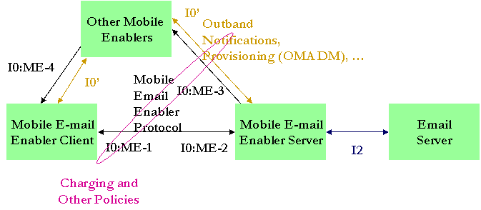
Figure 1 – Logical architecture for OMA Mobile E-mail enabler.

Functional Components and Interfaces
<< This section describes all of the architecture’s functional components and interfaces. Each of the components should be described in a separate subsection and MUST contain at least the following information:
- Name
- Description
- Responsibility (e.g. what does the component do/perform)
Each component SHOULD have at least one interface that can be used by some other functional component, enabler, application, etc.
All of the interfaces should be described in this section. The interfaces MUST be described in a language-independent way as required by [ARCH-PRINC].
Each interface description MUST include at least the following information:
- Name
- Description
- Entities in this enabler that will use the interface
Interface naming convention: The name of an interface consists of one, two, or three characters, followed by a dash, followed by a running number (starting at “1” and counting upwards in steps of 1 for each new interface). Each work group decides about the character(s) for their interfaces as long as there is no duplication with already existing names (work groups can consult ARCH to confirm). Interface names should be chosen in an intuitive way to allow easy recognition of the interface (e.g. based on what functionality is communicated over the interface). Some examples are:
B-1 B stands for “Browsing”
POC-5 POC stands for “Push to Talk over Cellular”
MMS-7 MMS stands for “Multimedia Messaging”
DELETE THIS COMMENT >>
The following main enabler components are identified:
- The mobile e-mail enabler client which implements the client-side functionality of the OMA Mobile Email Enabler. It is also responsible for providing the mobile e-mail user experience and interface to the user and storing the e-mail and data to be sent to the mobile e-mail enabler server when not connected.
- The mobile e-mail enabler server which implements the server-side functionality of the OMA Mobile Email Enabler.
- The mobile e-mail protocol between the Mobile Email Client and Mobile Email Enabling Server.
- It is responsible of all the data exchanges other than server to client event notifications that take place between the mobile e-mail enabler client and server in order to update the client with e-mail server changes, the email server with changes in the moble enabler email client and to send new email from the email server.
- Server to client notifications of e-mail server events can be transported via the mobile e-mail protocol. We then speak of inband notifications.
- Other OMA enablers are needed to support the mobile enabler:
- OMA DM and CP to support over the air installation of the mobile e-mail enabler client on the device, provisioning of its settings and revocation
- Messaging enablers for outband notification, where outband notifications that are server to client event exchanges not transported by the mobile e-mail protocol but via other channels. Such channels may involve:
- SMS including GSMSMS or WAP WDP a la EMN
- MMS
- WAP Push
Additional outband notifications like SIP push (SIP event notify) or UDP might also be used considered.
It should be noted that these notification mechanisms could be seen as part of a generic new OMA push / notification enabler.
The different interfaces that are identified are:
- ME-1: Mobile e-mail client enabler I0 interface to interact via the mobile e-mail enabler protocol with the mobile e-mail enabler server
- ME-2: corresponding I0 interface of the mobile enabler server
- ME-3: Mobile e-mail server enabler I0 interfaces to support generation of server to client notifications.
- ME-4: Mobile e-mail client enabler I0 interfaces to receive server to client notifications
In addition, the server and client may interfaces to the I0 interfaces of other mobile enablers (DM, CP, messaging). ME-3 and ME-4 may be bound on such interfaces.
According to the OSE [OSE], non-intrinsic functions can be provided by other enablers to enforce service providers policies like:
- Charging of the traffic
- Privacy and spam protection
These are not discussed in the present document.
The mobile e-mail enabler server enables an e-mail server. In a particular implementation, the email server may be packaged within (internal to it) the mobile e-mail enabler server or be in a separate component. In such cases, interfaces to the email server are provided via an I2 type of interface (out of scope of this work).

Flows
<< The objective of this section is to describe the high-level logical flows between the architectural entities.
DELETE THIS COMMENT >>

The high level logical flows associated to the mobile e-mail enabler are described below:
- Server to client notification:
  - An event (new e-mail, change of state of e-mail) takes place in the email server.
  - The mobile e-mail enabler server generates a notification, if prescribed by enabler settings and filtering rules (as set by administrator or user based on the type of event).
    - If outband notifications are used, the notification is sent in the appropriate channel:
      - E.g. as separate message through ME-3 (e.g. SIP event notify) or bound to another OMA messaging enabler (e.g. as a WAP Push message).
    - If inband notification is used (and therefore a ME-1/ME2 session is established), the notification is sent via ME-2 interface.
  - The mobile e-mail enabler client receives the notification:
    - Respectively via ME-4 (possibly bound to the I0’ of another enabler) or ME-1 I0’
  - Based on settings of the mobile e-mail eabler client, the client:
    - Updates its state (e.g. delete a local e-mail)
    - Queues the notification for the next time it retrives information from the server
    - Goes back to the mobile enabler server via ME-1 to act on the notification by retrieving appropriate data.
  - If no data connection is established between the client e-mail enabler server and the server e-mail enabler server, the client establishes a connection (including authentication etc…). If a connection exists (e.g. when using inband notification), this steps is not repeated.
  - Through ME-1 the client requests data from the mobile e-mail server to act on the notification. This is received by the mobile e-mail enabler server through its ME-2 interface.
  - The mobile e-mail enabler server provides (via ME-2) the requested data to the mobile e-mail enabler client (via ME-1).
  - The mobile e-mail enabler server may provide additional events and data for:
    - Notifications that it has previously sent to the client but to which the mobile e-mail enabler client never reacted (e.g. may have been lost) or that it had queued (e.g. because the mobile e-mail enabler client was not reachable and there was little value to continue to send server to client notifications.
    - Notifications for new server events that occurred since
    - Additional data and information needed by the server as described above.
This robustizes the behaviour of the enabler to intermittent connectivity and ureliable connectivity.
- Client events (deleted mail, readunread changes etc…) are sent (via ME-1) to the mobile e-mail enabler server (received via ME-2) if appropriate based on settings / filtering rules:
  - Depending if a connection exists or not, it is first established as described above when accessing additional data and events
  - After sending the data, the server may reply with data analogous to the notifications and data as descried above in answer to a request for more data.
The mobile e-mail enabler server then updates the appropriate e-mail server.
If the mobile e-mail enabler client can not connect to the mobile e-mail enabler server, the events are queued and stored in the client and sent when connection is eventually established.
- New e-mails are sent from the mobile e-mail enabler client (via ME-1) to the mobile e-mail enabler server (received via (ME-2) as for the previous case. The mobile e-mail enabler server then sends from the e-mails server. If the mobile e-mail enabler client can not connect to the mobile e-mail enabler server, the new e-mails are queued and stored in the client and sent to the mobile e-mail enabler server when connection is eventually established.
- The mobile e-mail enabler server and mobile e-mail enabler server can directly interact to support usage of the enabler:
  - Request more data from mobile e-mail enabler server (e.g. access more of an e-mail partially on the mobile e-mail enabler client).
  - Save of e-mail draft to mobile e-mail enabler server
  - Attachment manipulation:
    - Download an attachment
    - Convert an attachment (mime type / sub-type conversion or transcoding)
    - Server-side (partial) composition for reply / forward:
      - Forward without download
      - Partial edit and partial forward without download of:
        - Address fields,
        - Body
        - Attachments

- Change History (Informative)
<< The following is a model of a revision table. DELETE THIS COMMENT >>
  - Approved Version History
Reference | Date | Description
n/a | n/a | No prior version –or- No previous version within OMA
OMA-xxyyz-V1_0-20021001-A | 01 Oct 2002 | Initial document to address the basic starting point  Ref TP Doc# OMA-TP-2002-1234-xxyyzForApproval
OMA-xxyyz-V1_1-20030405-A | 05 Apr 2003 | description of changed  Ref TP Doc# OMA-TP-2003-0321-xxyyzV1_1forApproval
  - Draft/Candidate Version 1.0 History
<< This section is available in pre-approved versions – it should be removed in the actual approved versions. DELETE THIS COMMENT >>
Document Identifier | Date | Sections | Description
Draft Versions  OMA-AD-Mobile_Email-V1_0 | 21 Jun 2005 | All | Incorporates input OMA-MWG-2005-0057_Mobile_Email_AD_population
- Implementation considerations
If needed, add annex to provide additional information to support the document. In general, this information should be informative, as normative material should be contained in the primary body of the document.
Note that the styles for the headers in the appendix (App1, App2, App3) are different than the main body. The use below is intended to validate the styles to be used. Remove if not needed.
DELETE THIS COMMENT
  - Proxies and firewalls

[Mobile e-mail RD] requires that the mobile e-mail enabler must be compatible with firewalls. Figure 2 illustrates where firewalls may be present.
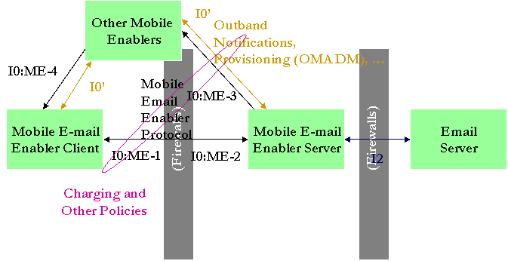
Figure 2 – Mobile e-mail enabler logical architecture and possible firewalls
To facilitate crossing the firewalls, it should be noted that the mobile e-mail enabler can be deployed via a mobile e-mail enabler proxy between ME-1 and ME-2. The proxy allows the Mobile Email Protocol through the firewalls in front of the mobile e-mail enabler server. The role of such a proxy is to allow the mobile e-mail enabler to be located in the same domain as the e-mail server in some deployment models and therefore alleviate the confidentiality and other security constraints that may be imposed on mobile e-mail enabler server implementations.
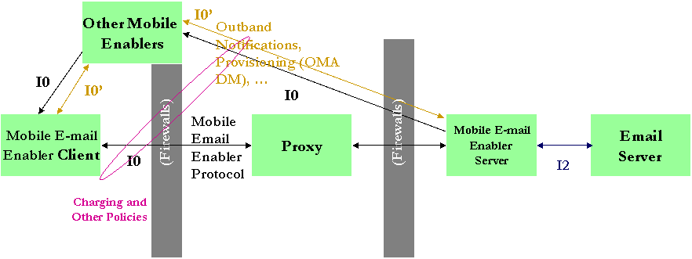
Figure 3 – Mobile e-mail enabler protocol proxy

  - Depoyment cases

The proposed logical architecture for the mobile e-mail enabler supports a rich set of deployment models illustrated in the following figures. This covers all the deployment case that have been envisaged to date. Note that the cases of Figure 8 and Figure 9 imply that mobile enabler must be compatible with end to end encryption between the e-mail server and mobile e-mail client. Such schemes must be introduced as part of the mobile e-mail enabler server implementation / I2 / e-mail server implementation when considering these deployments.
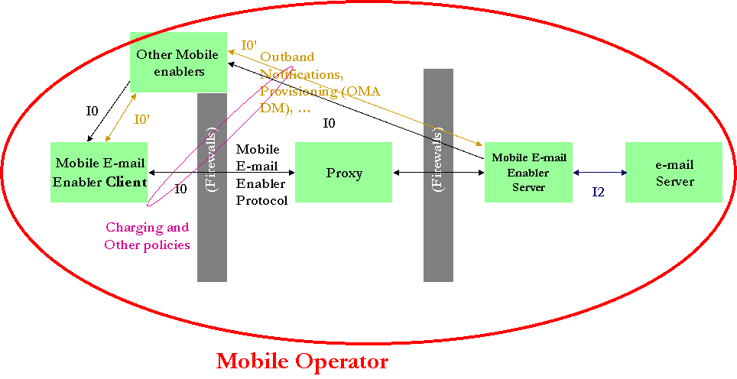
Figure 4 – Deployment within a mobile operator domain for an operator hosted e-mail service. The use of the proxy is optional.
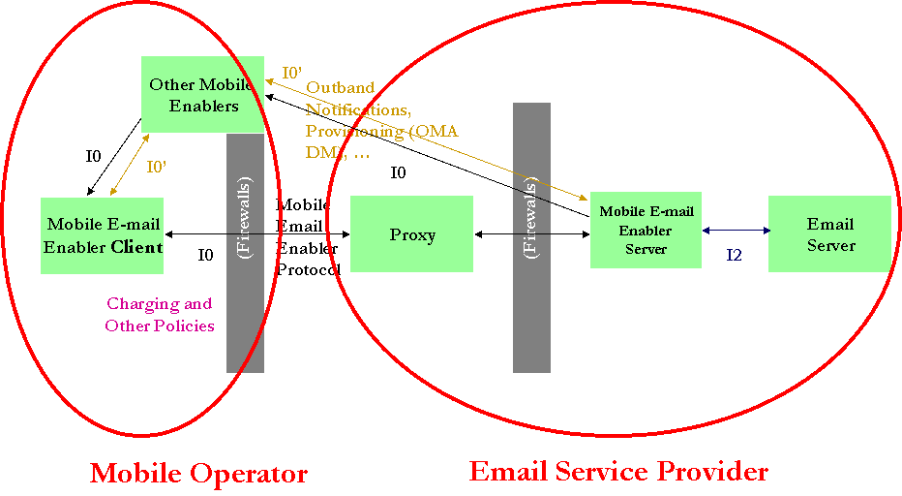
Figure 5 – Deployment by an e-mail service provider (enterprise or ISP (e.g. personal e-mail provider)). The proxy is deployed by the e-mail service provider in the DMZ. Other mobile enablement and transport are provided by the mobile service operator.

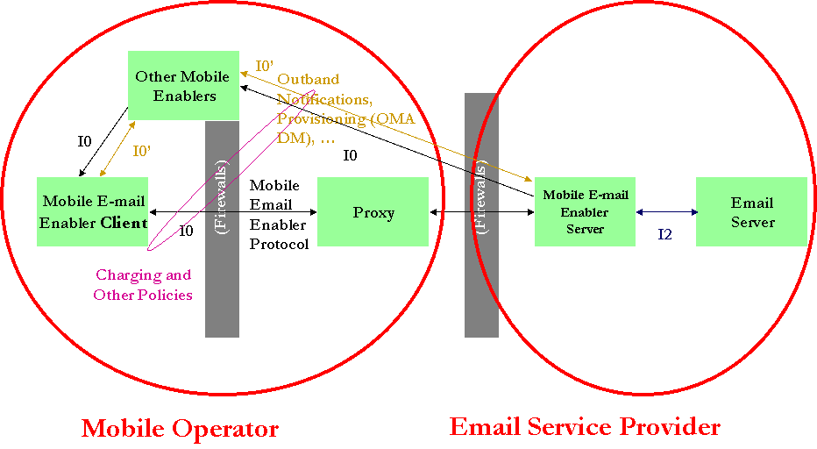
Figure 6 - Deployment by an e-mail service provider (enterprise or ISP (e.g. personal e-mail provider)). The proxy is provided as a service by the mobile operator. Other mobile enablement and transport are provided by the mobile service operator.
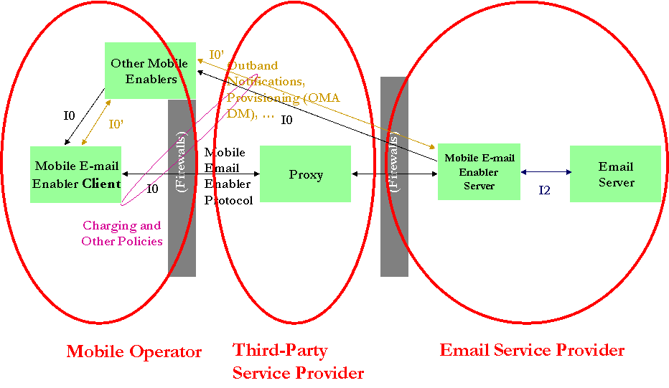
Figure 7 - Deployment by an e-mail service provider (enterprise or ISP (e.g. personal e-mail provider)). The proxy is provided as a service by a third party. Other mobile enablement and transport are provided by the mobile service operator.
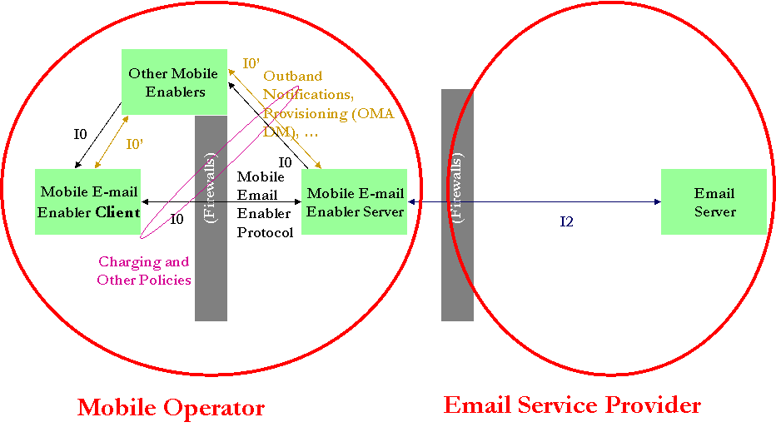
Figure 8 - Deployment by a mobile operator of a mobile e-mail enablement service offered to e-mail service provider (enterprise or ISP (e.g. personal e-mail provider)). All mobile enablement and transport are provided by the mobile service operator. All data must remain end-to-end secure, including at the level of the mobile e-mail enabler server implementation.

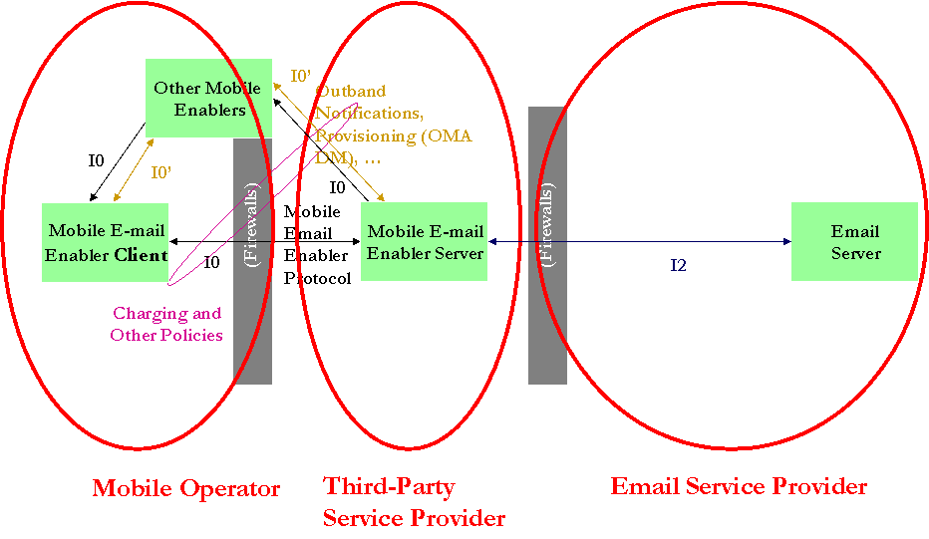
Figure 9 - Deployment by a third party service provider of a mobile e-mail enablement service offered to e-mail service provider (enterprise or ISP (e.g. personal e-mail provider)). Other mobile enablement and transport are provided by the mobile service operator. All data must remain end-to-end secure, including at the level of the mobile e-mail enabler server implementation.

